**IT STANDARDS**

**ISO Software Testing Standards**

ISO/IEC/IEEE having number 29119 is intended for software testing acts as an internationally approved collection of standards in software testing which is followed for any SDLC model in developing software for any organization. When you implement the standards, you adopt the internationally-recognized and approved testing standards that will eventually offer your organization a quality approach for testing.

We have five standards within the***ISO/IEC 29119*** international software testing standard.

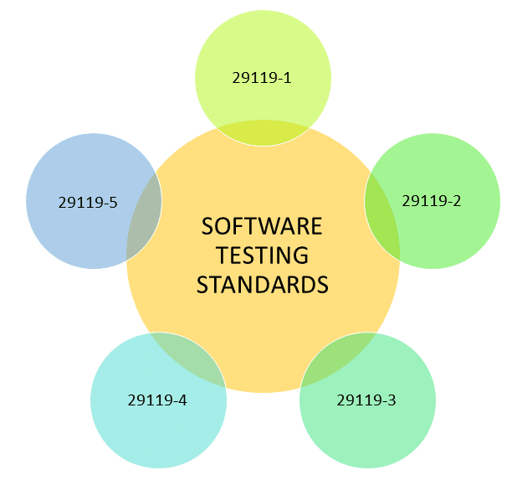

* **ISO/IEC 29119-1**: This Standard deals with concepts and definitions of software. (published in Sep 2013)
* **ISO/IEC 29119-2**: This Standard deals with test processes in a product. (published in Sep 2013)
* **ISO/IEC 29119-3**: This Standard deals with test documentation of the product. (published in Sep 2013)
* **ISO/IEC 29119-4**: This Standard deals with testing techniques and strategies used in software testing.
* **ISO/IEC 29119-5**: This Standard was published deals with keyword-based software testing. (published in the year 2015).

**ISO/IEC 9126:**

This is a popular software testing standard that deals with below-mentioned characteristics for determining the product quality in the testing phase:

* Modelling Quality
* Inner metrics
* External metrics
* Quality in the usage of metrics

Some precise set of the quality feature needs to be followed for all products while standards are being set. These features are set in such a way that they meet all the boundary requirements of a software and test cases. These are as follows:

* Proper functionality of the software
* User's reliability of software
* Usability of software (high tuned user experience)
* High efficiency
* Proper maintainability
* All aspects of portability

**IEEE:**The **Institute of Electrical and Electronics Engineers (IEEE)** having its corporate office in New York City and its operations center in Piscataway, New Jersey. As of 2018, it has more than 423,000 members in over 160 countries around the world. The main purpose of the IEEE series is to provide such guidelines that can be used by any organization when performing any form of software testing

|  |  |
| --- | --- |
| Standard | Description |
| IEEE 829 | This standard is used for proper document formatting and is practiced in different  stages of software testing |
| IEEE 1061 | It has the technique to establish better quality and validating the software with  the quality metrics |
| IEEE 1059 | Supports in guiding software verification and validation |
| IEEE 1008 | Standard which supports proper unit testing |
| IEEE 1012 | Standard that supports Verification and Validation of product |
| IEEE 1028 | Standard that guides in proper software inspections |
| IEEE 1044 | Standard which categorizes the various anomalies in software |
| IEEE 830 | Standard that helps following the proper development of a system with  accurate requirements specifications |
| IEEE 730 | Standard that deals with the product's quality assurance |
| IEEE 1061 | Standard that deals with the product's quality metrics |
| IEEE 12207 | Standard that guides in proper life cycle processes of both data and software |